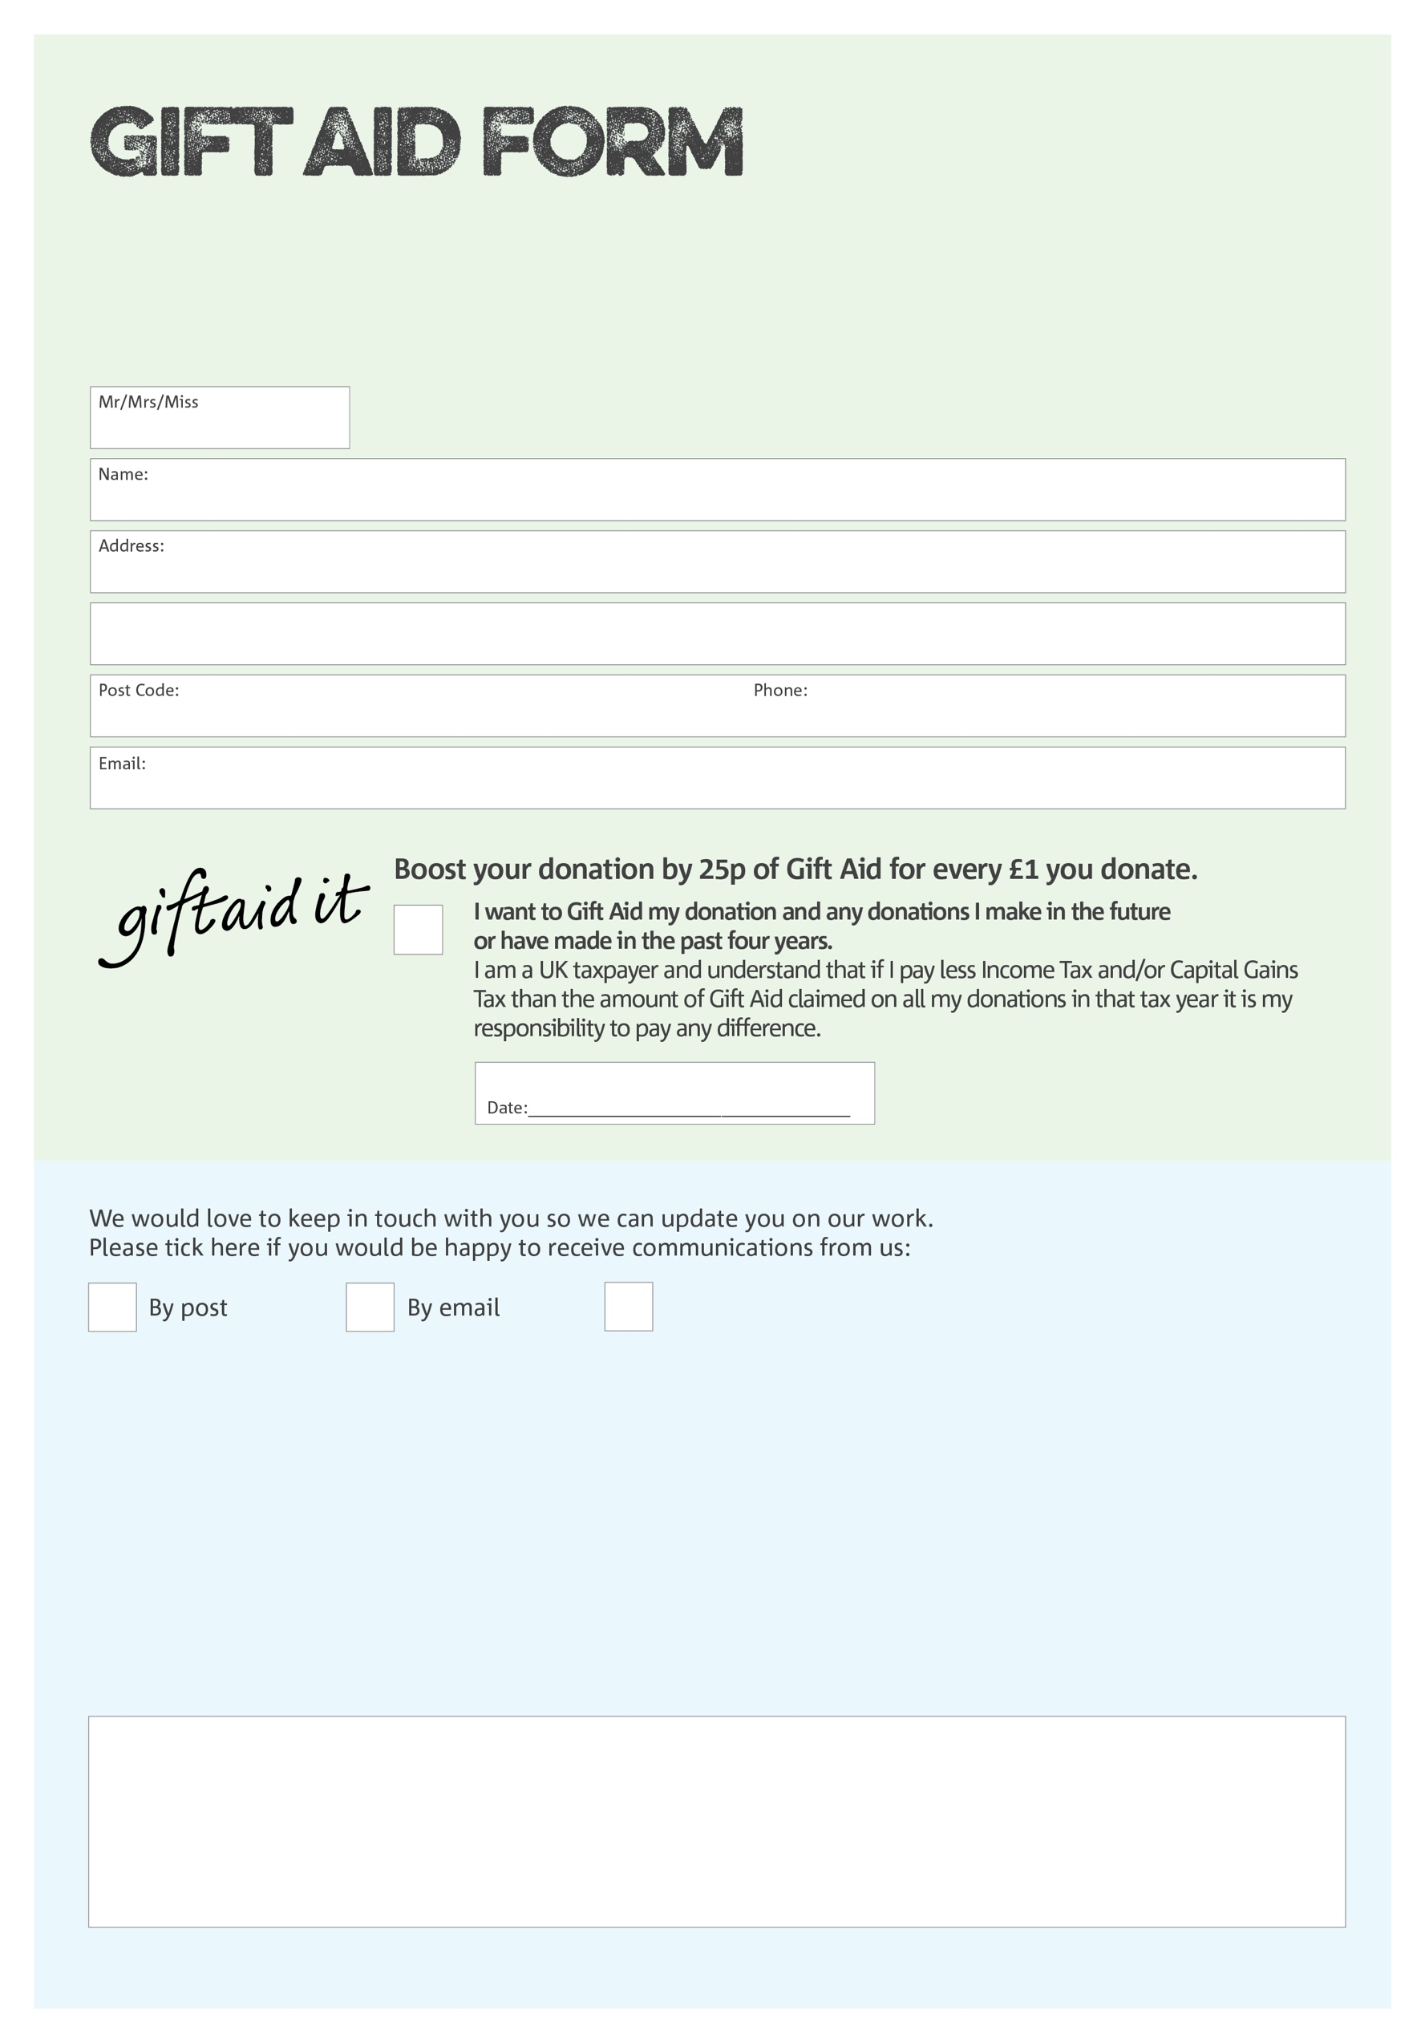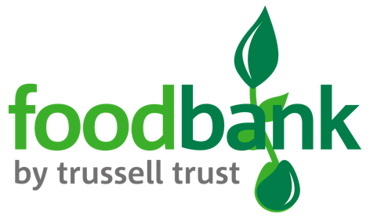

By filling in this form Redditch Foodbank will receive an extra 25p for every £1 you give at no extra cost to you. Thank you!

**IMPORTANT**

Please make all cheques payable to “**Acts of Kindness**”, as the charity that oversees Redditch Foodbank. We will not be able to bank cheques payable to Redditch Foodbank. Thank you!

**Data protection**

Redditch Foodbank is committed to protecting your privacy and will process your personal data in accordance with Data Protection legislation. Redditch Foodbank collects information to keep in touch with you and supply you with information relating to our work. Redditch Foodbank will never sell or pass your details to anyone who isn’t directly working on our behalf.

*To unsubscribe from our newsletter, send a message to the email address above with the word unsubscribe in the subject line. A full data privacy statement for financial donors is available from the foodbank on request.’*

You can change your preferences any time by contacting us on 07847 618539 or emailing us at info@redditch.foodbank.org.uk

I do not wish to receive future communications from Redditch Foodbank

Charity Number1157916. Registered in 2014