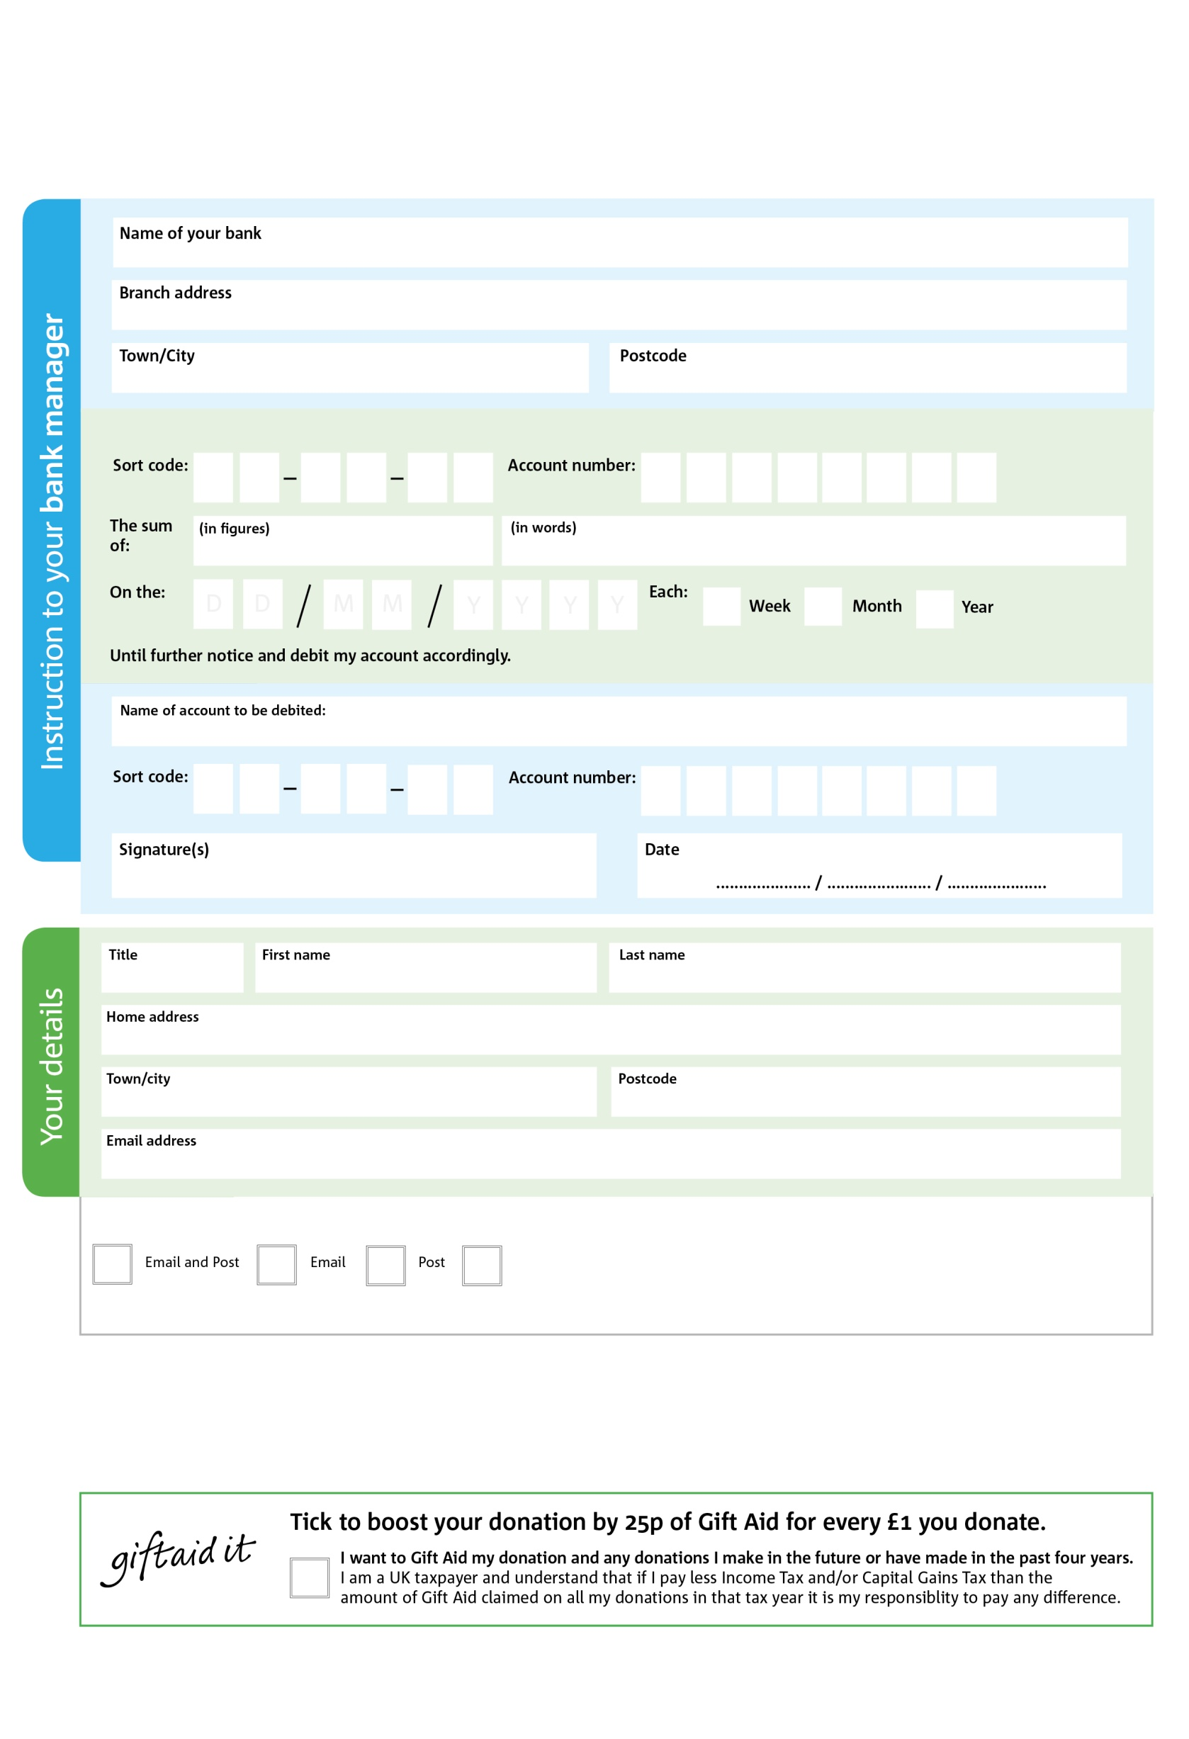

You can change your preferences any time by contacting us on 07847 618539 or emailing us at manager@redditch.foodbank.org.uk

**Please pass this form onto the foodbank, using the foodbank’s address at the bottom, who will save a copy for their records. They will then send it onto your named bank or building society.**

8

V

3

V

5

V

3

V

7

V

7

V

8

V

3

V

5

3

0

3

4

54

We would love to keep you up to date with information about Redditch Foodbank. Please tick your preference:

I do not wish to receive future communications from Redditch Foodbank

Please pay Acts of Kindness,

**Data protection**

*Redditch Foodbank is committed to protecting your privacy and will process your personal data in accordance with current Data Protection legislation. Redditch Foodbank collects information to keep in touch with you and supply you with information relating to our work. To unsubscribe from our newsletter, send a message to the email address above with the word unsubscribe in the subject line. A full data privacy statement for financial donors is available from the foodbank on request.’*

**Standing Order Mandate**

**Redditch.foodbank.org.uk**

Reg. Charity No1157916 | Reg. in England & Wales

POSTAL ADDRESS: Redditch Foodbank, Unit 18, Winyates Centre, Redditch B98 0NR

You can change your preferences any time by contacting us on XXXXXXXXXXX or emailing us at XXXX@XXXXXXXXXX.foodbank.org.uk

I do not wish to receive future communications from XXXXXX Foodbank